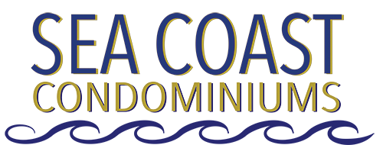

SEA COAST MANAGEMENT, INC.
A Corporation Not-for Profit

NOTICE OF BOARD OF DIRECTORS MEETING

SEA COAST CONDOMINIUM CLUBHOUSE

SATURDAY – FEBRUARY 15, 2020

10:00 AM – 11:30 AM Dial-In: 401-347-0571 Participant PIN: 89955

- CALL MEETING TO ORDER

- PROOF OF NOTICE OF MEETING

- APPROVE MINUTES OF NOVEMBER 2019 MEETING

- TREASURER’S REPORT

- MANAGER’S REPORT

- OLD BUSINESS

  - Spectrum Rewire Completion
  - West Stairwell Status
  - Elevator Repair Status
  - RL James Warranty & New Work Completion
  - Water Heater Proposal
  - RSF Delinquency/Non-Payment
  - Access Control Status
  - Other Old Business

- NEW BUSINESS

  - Committee Reports
  - Other New Business

- ADJOURNMENT

